Supplementary material of the manuscript titled “A Geo-Spatial Based Bibliometric Analysis of Global Research Trends in Construction Project Delays: Cause Analysis, Prediction and Management”

Table S1. Annual publication counts related to the analysis, prediction, and management of delays in construction projects.
Delay Analysis |  | Delay Prediction |  | Delay Management
Year | Publications | Category | Publications | Year | Publications
2012 | 113 | 2012 | 37 | 2012 | 3
2013 | 135 | 2013 | 54 | 2013 | 3
2014 | 141 | 2014 | 52 | 2014 | 2
2015 | 183 | 2015 | 64 | 2015 | 4
2016 | 197 | 2016 | 71 | 2016 | 3
2017 | 236 | 2017 | 94 | 2017 | 2
2018 | 333 | 2018 | 131 | 2018 | 13
2019 | 345 | 2019 | 140 | 2019 | 12
2020 | 450 | 2020 | 172 | 2020 | 22
2021 | 476 | 2021 | 184 | 2021 | 16
2022 | 616 | 2022 | 260 | 2022 | 28
2023 | 694 | 2023 | 291 | 2023 | 22

(a)
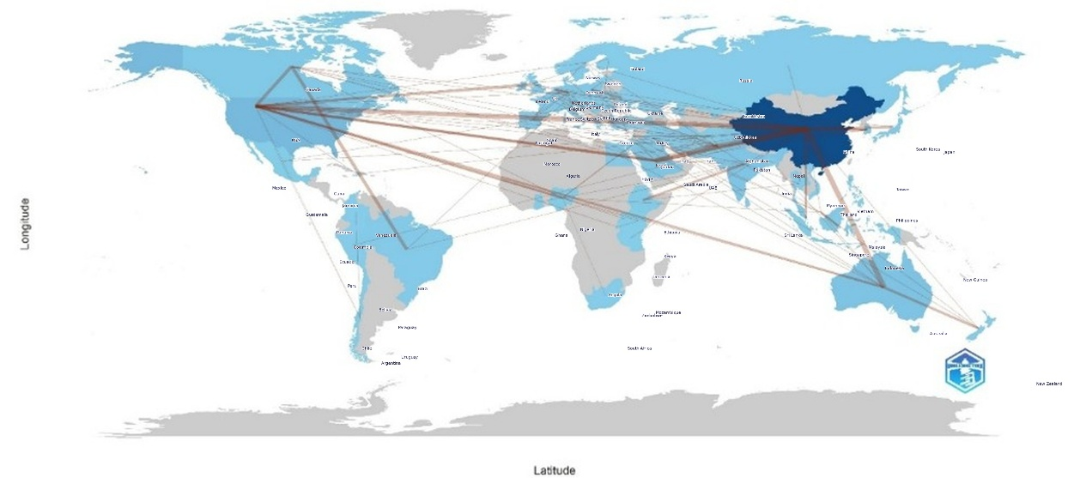
(b)
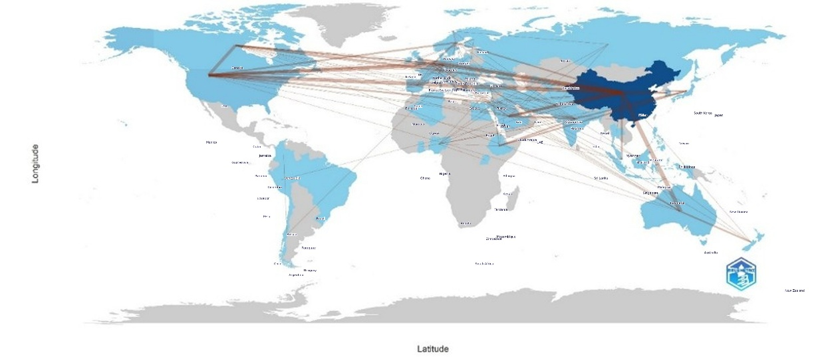
(c)
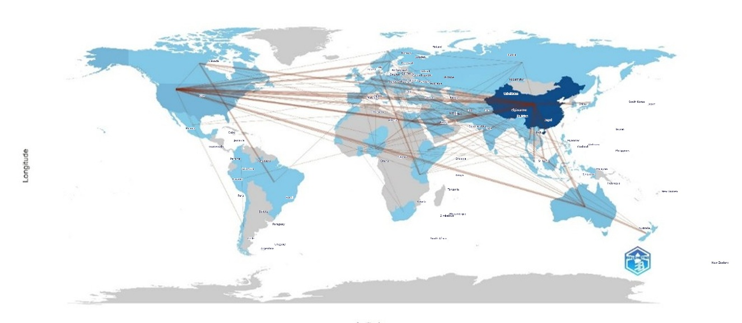
Figure S1. Geographical map of leading countries determined by publications related to: (a) analysis, (b) prediction, and (c) management of delay in construction projects.

Table S2. Characteristics of country collaboration network related to analysis, prediction, and management of delays in construction projects.
Construction Delay Analysis |  |  | Construction Delay Prediction |  |  | Construction Delay Management
From | To | Frequency | From | To | Frequency | From | To | Frequency
Saudi Arabia | Pakistan | 7 | China | Australia | 8 | Saudi Arabia | Pakistan | 7
China | Australia | 6 | China | USA | 6 | China | Pakistan | 6
China | Pakistan | 6 | China | Germany | 5 | China | USA | 5
China | USA | 5 | USA | Canada | 5 | China | Australia | 3
Brazil | Canada | 3 | USA | Germany | 5 | China | Netherlands | 3
China | Saudi Arabia | 3 | China | Pakistan | 4 | Saudi Arabia | Egypt | 3
USA | Canada | 3 | China | United Kingdom | 4 | USA | Australia | 3
Australia | New Zealand | 2 | China | Canada | 3 | Australia | New Zealand | 2
China | Japan | 2 | China | Saudi Arabia | 3 | Brazil | Canada | 2
China | Korea | 2 | Saudi Arabia | Pakistan | 3 | China | Canada | 2

